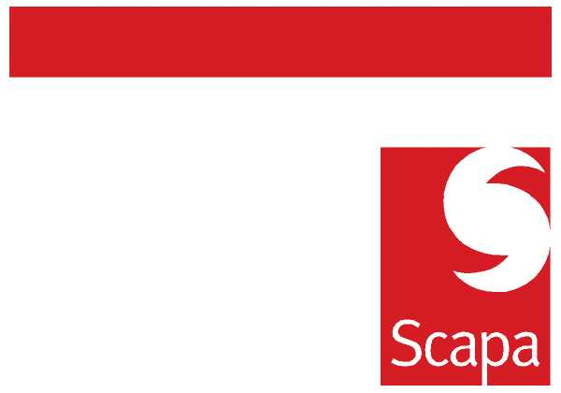

ANNOUNCEMENT

It is with much regret that I have to announce that Sergio Colonnelli has decided to leave Scapa to pursue new personal interests.

Sergio started his management career at Pirelli Industries in Milan and after managing various sales and business units within Pirelli he joined Adenax spa, the tape division of Pirelli as Head of Sales. In 1986 Scapa acquired Adenax and Sergio played a pivotal role in the creation of the newly formed Scapa Adhesive Tape division. Concentrating on the Industrial markets, Sergio’s people management and language skills allowed Scapa to develop the first truly European team.

Sergio’s ability to build senior level relationships with key customers and key distributors has set standards within the Scapa organisation and remains one of Sergio’s core skills. Framed by trust and always operating with the company’s best interests in mind, Sergio has developed respect inside and outside of Scapa for his knowledge, integrity and elegance. He has also been a driving force in the growth of the Industrial business and its managers.

Over the coming weeks Sergio will support the transition of Industrial Business.

We wish Sergio and his family the very best for the future.

Building upon the work that Sergio has done a follow up announcement will be made regarding Industrial.

Barry Andrew

14 April 2010

